MODULE –V
Cloud Platforms in Industry
Cloud Platforms in Industry
An overview of a few prominent cloud computing platforms and a brief description of the types of service they offer. A cloud computing system can be developed using either a single technology and vendor or a combination of them. This chapter presents some of representative cloud computing solutions offered as Infrastructure-as-a-Service (IaaS) and Platform-as-a-Service (PaaS) services in the market.
Amazon web services
- Compute services
- Storage services
- Communication services

Amazon web services
Amazon Web Services (AWS) is a platform that allows the development of flexible applications by providing solutions for elastic infrastructure scalability, messaging, and data storage. The platform is accessible through SOAP or RESTful Web service interfaces and provides a Web-based console where users can handle administration and monitoring of the resources required, as well as their expenses computed on a pay-as-you-go basis.
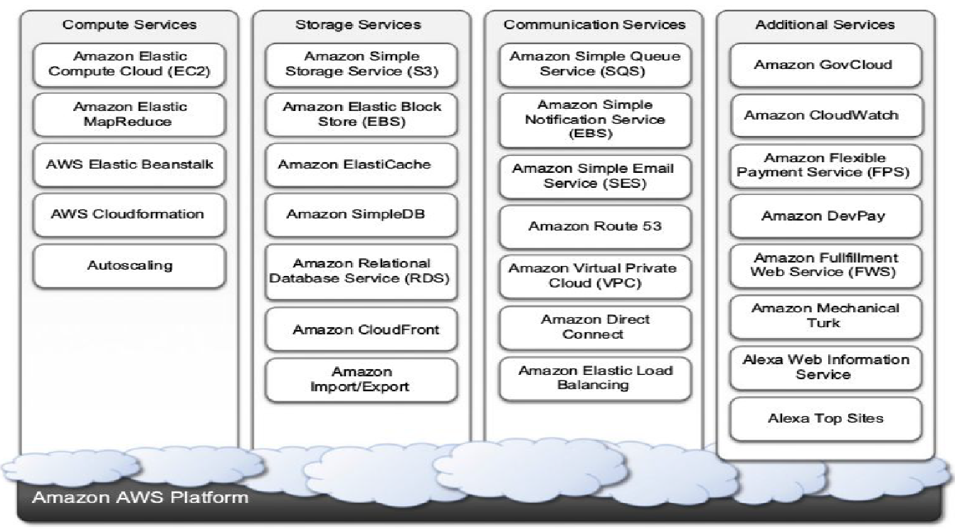
Figure 5.1: Amazon web services echo system
Figure 5.1 shows all the services available in the AWS ecosystem. At the base of the solution stack are services that provide raw compute and raw storage: Amazon Elastic Compute (EC2) and Amazon Simple Storage Service (S3).
Compute services
The fundamental service in this space is Amazon EC2, which delivers an IaaS solution that has served as a reference model for several offerings from other vendors in the same market segment.
Amazon EC2 allows deploying servers in the form of virtual machines created as instances of a specific image. Images come with a preinstalled operating system and a software stack, and instances can be configured for memory, number of processors, and storage.

Users are provided with credentials to remotely access the instance and further configure or install software if needed.
1. Amazon machine images
2. EC2 instances
3. EC2 environment
4. Advanced compute services

Amazon machine images
Amazon Machine Images (AMIs) are templates from which it is possible to create a virtual machine. They are stored in Amazon S3 and identified by a unique identifier in the form of ami-xxxxxx and a manifest XML file. AMI contains physical file system layout with a predefined operating system installed as Amazon Ramdisk Image (ARI, id: ari-yyyyyy) and the Amazon Kernel Image (AKI, id: aki-zzzzzz) A common practice is to prepare new AMIs to create an instance from a preexisting AMI, log into it once it is booted and running, and install all the software needed.
Using the tools provided by Amazon, we can convert the instance into a new image. Once an AMI is created, it is stored in an S3 bucket and the user can decide whether to make it available to other users or keep it for personal use.
EC2 instances
EC2 instances represent virtual machines. They are created using AMI as templates, which are specialized by selecting the number of cores, their computing power, and the installed memory. The processing power is expressed in terms of virtual cores and EC2 Compute Units (ECUs). The use of ECUs helps give users a consistent view of the performance offered by EC2 instances. One ECU is defined as giving the same performance as a 1.0 - 1.2 GHz 2007 Opteron or 2007 Xeon processor.
We can identify six major configurations for EC2 instances.
● Standard instances. Offers set of configurations that are suitable for most applications. EC2 provides three different categories of increasing computing power, storage, and memory.
● Micro instances. Suitable for those applications that consume limited amount of computing power and memory and need bursts in CPU cycles to process surges in workload.
● High-memory instances. Targets applications that need to process huge workloads and require large amounts of memory. Three-tier Web applications characterized by high traffic are the target profile.
● High-CPU instances. Targets compute-intensive applications.
● Cluster Compute instances. Used to provide virtual cluster services. Instances in this category are characterized by high CPU compute power and large memory and an extremely high I/O and network performance, which makes it suitable for HPC applications.
● Cluster GPU instances. Provides instances featuring graphic processing units (GPUs) and high compute power, large memory, and extremely high I/O and network performance. This class is particularly suited for cluster applications that perform heavy graphic computations.

EC2 environment
EC2 instances are executed within a virtual environment. The EC2 environment is in charge of allocating addresses, attaching storage volumes, and configuring security in terms of access control and network connectivity. It is possible to associate an Elastic IP to each instance. Elastic IPs allow instances running in EC2 to act as servers reachable from the Internet. EC2 instances are given domain name in the form ec2-xxx-xxx-xxx.compute-x.amazonaws.com, where xxx-xxx-xxx normally represents the four parts of the external IP address separated by a dash, and compute-x gives information about the availability zone where instances are deployed.

Currently, there are five availability zones: two in the United States (Virginia and Northern California), one in Europe (Ireland), and two in Asia Pacific (Singapore and Tokyo).

Advanced compute services
AWS CloudFormation constitutes an extension of the simple deployment model that characterizes EC2 instances. CloudFormation introduces the concepts of templates, which are JSON formatted text files that describe the resources needed to run an application or a service in EC2 together.
Templates provide a simple and declarative way to build complex systems and integrate EC2 instances with other AWS services such as S3, SimpleDB, SQS, SNS, Route 53, Elastic Beanstalk, and others.
AWS Elastic Beanstalk constitutes a simple and easy way to package applications and deploy them on the AWS Cloud. This service simplifies the process of provisioning instances and deploying application code and provides appropriate access to them. Currently, this service is available for Web applications developed with the Java/Tomcat technology stack. Beanstalk simplifies tedious tasks without removing the user’s capability of accessing—and taking over control of—the underlying EC2 instances.
Amazon Elastic MapReduce provides AWS users with a cloud computing platform for MapReduce applications. It utilizes Hadoop as the MapReduce engine, deployed on a virtual infrastructure composed of EC2 instances, and uses Amazon S3 for storage needs. Elastic MapReduce introduces elasticity and allows users to dynamically size the Hadoop cluster according to their needs, as well as select the appropriate configuration of EC2 instances to compose the cluster.

Storage services
The core service is represented by Amazon Simple Storage Service (S3). This is a distributed object store that allows users to store information in different formats. The core components of S3 are two: buckets and objects. Buckets represent virtual containers in which to store objects; objects represent the content that is actually stored. Objects can also be enriched with metadata that can be used to tag the stored content with additional information.
1 S3 key concepts
2 Amazon elastic block store
3 Amazon ElastiCache
4 Structured storage solutions
5 Amazon CloudFront

S3 key concepts
S3 has been designed to provide a simple storage service that’s accessible through a Representational State Transfer (REST) interface.
● the storage is organized in a two-level hierarchy.
● Stored objects cannot be manipulated like standard files.
● Content is not immediately available to users.
● Requests will occasionally fail.
Access to S3 is provided with RESTful Web services. These express all the operations that can be performed on the storage in the form of HTTP requests (GET, PUT, DELETE, HEAD, and POST).
Resource naming
Buckets, objects, and attached metadata are made accessible through a REST interface. Therefore, they are represented by uniform resource identifiers (URIs) under the s3.amazonaws.com domain.
Amazon offers three different ways of addressing a bucket:
1. Canonical form: http://s3.amazonaws.com/bukect_name/
2. Subdomain form: http://bucketname.s3.amazon.com/
3. Virtual hosting form: http://bucket-name.com/
Buckets
A bucket is a container of objects. It can be thought of as a virtual drive hosted on the S3 distributed storage, which provides users with a flat store to which they can add objects. Buckets are top-level elements of the S3 storage architecture and do not support nesting. That is, it is not possible to create “subbuckets” or other kinds of physical divisions.
Objects and metadata
Objects constitute the content elements stored in S3. Users either store files or push to the S3 text stream representing the object’s content. An object is identified by a name that needs to be unique within the bucket in which the content is stored. The name cannot be longer than 1,024 bytes when encoded in UTF-8, and it allows almost any character. Buckets do not support nesting.
Access control and security
Amazon S3 allows controlling the access to buckets and objects by means of Access Control Policies (ACPs). An ACP is a set of grant permissions that are attached to a resource expressed by means of an XML configuration file. A policy allows defining up to 100 access rules, each of them granting one of the available permissions to a grantee.

Currently, five different permissions can be used:
A. READ allows the grantee to retrieve an object and its metadata and to list the content of a bucket as well as getting its metadata.
B. WRITE allows the grantee to add an object to a bucket as well as modify and remove it.
C. READ_ACP allows the grantee to read the ACP of a resource.
D. WRITE_ACP allows the grantee to modify the ACP of a resource.
E. FULL_CONTROL grants all of the preceding permissions.

Amazon elastic block store
The Amazon Elastic Block Store (EBS) allows AWS users to provide EC2 instances with persistent storage in the form of volumes that can be mounted at instance startup. They accommodate up to 1 TB of space and are accessed through a block device interface, thus allowing users to format them according to the needs of the instance they are connected to.

EBS volumes normally reside within the same availability zone of the EC2 instances that will use them to maximize the I/O performance. It is also possible to connect volumes located in different availability zones. Once mounted as volumes, their content is lazily loaded in the background and according to the request made by the operating system. This reduces the number of I/O requests that go to the network.
Amazon ElastiCache
ElastiCache is an implementation of an elastic in-memory cache based on a cluster of EC2 instances. It provides fast data access through a Memcached-compatible protocol so that applications can transparently migrate to ElastiCache. ElastiCache is based on a cluster of EC2 instances running the caching software, which is made available through Web services. An ElastiCache cluster can be dynamically resized according to the demand of the client applications.
Structured storage solutions
Amazon provides applications with structured storage services in three different forms:
● Preconfigured EC2 AMIs,
● Amazon Relational Data Storage (RDS), and
● Amazon SimpleDB.
Preconfigured EC2 AMIs are predefined templates featuring an installation of a given database management system. EC2 instances created from these AMIs can be completed with an EBS volume for storage persistence. Available AMIs include installations of IBM DB2, Microsoft SQL Server, MySQL, Oracle, PostgreSQL, Sybase, and Vertica.
RDS is relational database service that relies on the EC2 infrastructure and is managed by Amazon. Developers do not have to worry about configuring the storage for high availability, designing failover strategies, or keeping the servers up-to-date with patches. Moreover, the service provides users with automatic backups, snapshots, point-in-time recoveries, and facilities for implementing replications.
Amazon SimpleDB is a lightweight, highly scalable, and flexible data storage solution for applications that do not require a fully relational model for their data. SimpleDB provides support for semi structured data, the model for which is based on the concept of domains, items, and attributes. SimpleDB uses domains as top-level elements to organize a data store. These domains are roughly comparable to tables in the relational model. Unlike tables, they allow items not to have all the same column structure; each item is therefore represented as a collection of attributes expressed in the form of a key-value pair.
Amazon CloudFront
CloudFront is an implementation of a content delivery network on top of the Amazon distributed storage infrastructure. It leverages a collection of edge servers strategically located around the globe to better serve requests for static and streaming Web content so that the transfer time is reduced.
AWS provides users with simple Web service APIs to manage CloudFront.
To make available content through CloudFront, it is necessary to create a distribution. This identifies an origin server, which contains the original version of the content being distributed, and it is referenced by a DNS domain under the Cloudfront.net domain name. The content that can be delivered through CloudFront is static (HTTP and HTTPS) or streaming (Real Time Messaging Protocol, or RMTP).
Communication services
Amazon provides facilities to structure and facilitate the communication among existing applications and services residing within the AWS infrastructure. These facilities can be organized into two major categories:
1. Virtual networking and
2. Messaging.
Virtual networking
Virtual networking comprises a collection of services that allow AWS users to control the connectivity to and between compute and storage services. Amazon Virtual Private Cloud (VPC) and Amazon Direct Connect provide connectivity solutions in terms of infrastructure. Amazon VPC provides flexibility in creating virtual private networks within the Amazon infrastructure and beyond. The service providers prepare templates for network service for advanced configurations. Templates include public subnets, isolated networks, and private networks accessing Internet through network address translation (NAT), and hybrid networks including AWS resources and private resources.

Amazon Direct Connect allows AWS users to create dedicated networks between the user private network and Amazon Direct Connect locations, called ports. This connection can be further partitioned in multiple logical connections and give access to the public resources hosted on the Amazon infrastructure. The advantage is the consistent performance of the connection between the user’s premises and the Direct Connect locations. Amazon Route 53 implements dynamic DNS services that allow AWS resources to be reached through domain names different from the amazon.com domain. By leveraging the large and globally distributed network of Amazon DNS servers.
Messaging.
The three different types of messaging services offered are
● Amazon Simple Queue Service (SQS),
● Amazon Simple Notification Service (SNS), and
● Amazon Simple Email Service (SES).
Amazon SQS constitutes disconnected model for exchanging messages between applications by means of message queues, hosted within the AWS infrastructure. Using the AWS console or directly the underlying Web service AWS, users can create an unlimited number of message queues and configure them to control their access. Applications can send messages to any queue they have access to. These messages are securely and redundantly stored within the AWS infrastructure for a limited period of time, and they can be accessed by other (authorized) applications.

Amazon SNS provides a publish-subscribe method for connecting heterogeneous applications. Amazon SNS allows applications to be notified when new content of interest is available. This feature is accessible through a Web service whereby AWS users can create a topic, which other applications can subscribe.
Amazon SES provides AWS users with a scalable email service that leverages the AWS infrastructure. Once users are signed up for the service, they have to provide an email that SES will use to send emails on their behalf. To activate the service, SES will send an email to verify the given address and provide the users with the necessary information for the activation.
Google AppEngine
Google AppEngine is a PaaS implementation. Distributed and scalable runtime environment that leverages Google’s distributed infrastructure to scale out applications.
Architecture and core concepts
AppEngine is a platform for developing scalable applications accessible through the Web. Figure 5.2. The platform is logically divided into four major components: infrastructure, the runtime environment, the underlying storage, and the set of scalable services.
Infrastructure
AppEngine hosts Web applications, and its primary function is to serve users requests efficiently.
AppEngine’s infrastructure takes advantage of many servers available within Google datacenters. For each HTTP request, AppEngine locates the servers hosting the application that processes the request, evaluates their load, and, if necessary, allocates additional resources or redirects the request to an existing server. The infrastructure is also responsible for monitoring application performance and collecting statistics on which the billing is calculated.
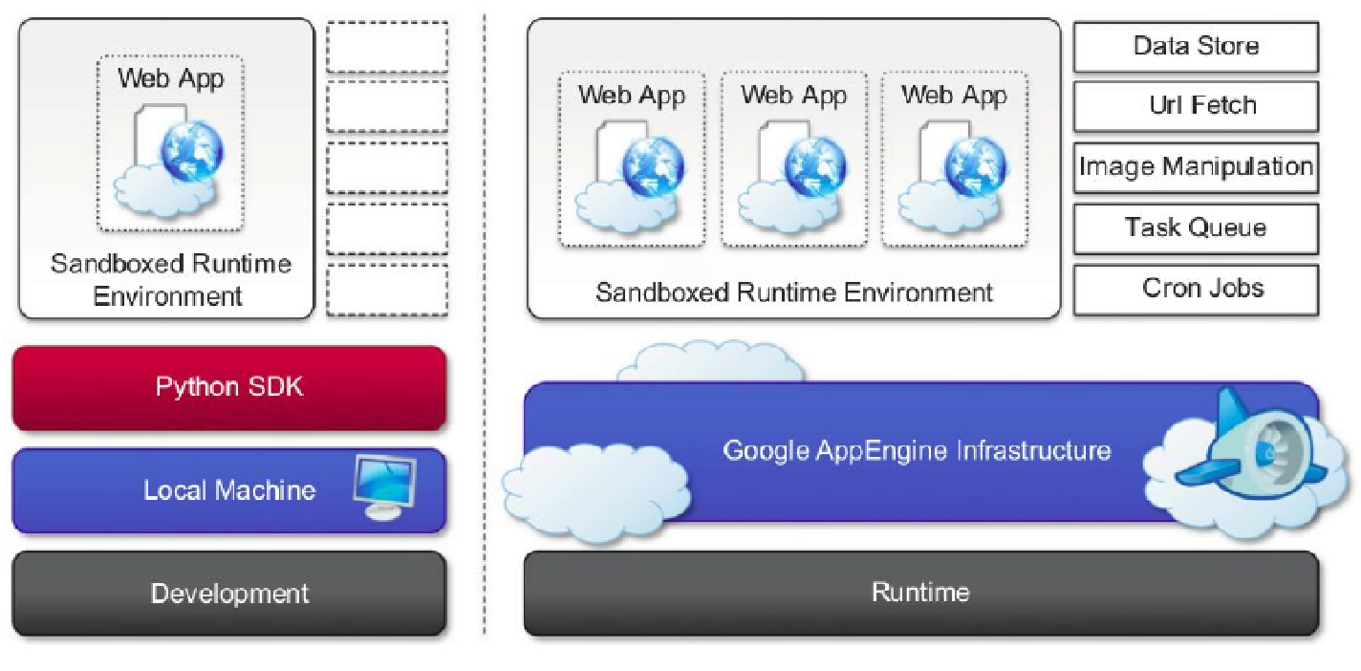
Figure 5.2: Google AppEngine platform architecture
Runtime environment
The runtime environment represents the execution context of applications hosted on AppEngine.
Sandboxing- One of the major responsibilities of the runtime environment is to provide the application environment with an isolated and protected context in which it can execute without causing a threat to the server and without being influenced by other applications. In other words, it provides applications with a sandbox. If an application tries to perform any operation that is considered potentially harmful, an exception is thrown and the execution is interrupted.
Supported runtimes - Currently, it is possible to develop AppEngine applications using three different languages and related technologies: Java, Python, and Go. AppEngine currently supports Java 6, and developers can use the common tools for Web application development in Java, such as the Java Server Pages (JSP), and the applications interact with the environment by using the Java Servlet standard.
Storage
AppEngine provides various types of storage, which operate differently depending on the volatility of the data.
Static file servers - Web applications are composed of dynamic and static data. Dynamic data are a result of the logic of the application and the interaction with the user. Static data often are mostly constituted of the components that define the graphical layout of the application or data files.
DataStore- DataStore is a service that allows developers to store semistructured data. The service is designed to scale and optimized to quickly access data. DataStore can be considered as a large object database in which to store objects that can be retrieved by a specified key. DataStore imposes less constraint on the regularity of the data but, at the same time, does not implement some of the features of the relational model. The underlying infrastructure of DataStore is based on Bigtable, a redundant, distributed, and semistructured data store that organizes data in the form of tables.

DataStore provides high-level abstractions that simplify interaction with Bigtable. Developers define their data in terms of entity and properties, and these are persisted and maintained by the service into tables in Bigtable. DataStore also provides facilities for creating indexes on data and to update data within the context of a transaction. Indexes are used to support and speed up queries. A query can return zero or more objects of the same kind or simply the corresponding keys.
Application services
Applications hosted on AppEngine take the most from the services made available through the runtime environment. These services simplify most of the common operations that are performed in Web applications.
UrlFetch - The sandbox environment does not allow applications to open arbitrary connections through sockets, but it does provide developers with the capability of retrieving a remote resource through HTTP/HTTPS by means of the UrlFetch service. Applications can make synchronous and asynchronous Web requests and integrate the resources obtained in this way into the normal request- handling cycle of the application. UrlFetch is not only used to integrate meshes into a Web page but also to leverage remote Web services in accordance with the SOA reference model for distributed applications.

MemCache- This is a distributed in-memory cache that is optimized for fast access and provides developers with a volatile store for the objects that are frequently accessed. The caching algorithm implemented by MemCache will automatically remove the objects that are rarely accessed. The use of MemCache can significantly reduce the access time to data; developers can structure their applications so that each object is first looked up into MemCache and if there is a miss, it will be retrieved from DataStore and put into the cache for future lookups.
Mail and instant messaging- AppEngine provides developers with the ability to send and receive mails through Mail. The service allows sending email on behalf of the application to specific user accounts. It is also possible to include several types of attachments and to target multiple recipients.
AppEngine provides also another way to communicate with the external world: the Extensible Messaging and Presence Protocol (XMPP). Any chat service that supports XMPP, such as Google Talk, can send and receive chat messages to and from the Web application, which is identified by its own address.
Account management - AppEngine simplifies account management by allowing developers to leverage Google account management by means of Google Accounts. Using Google Accounts, Web applications can conveniently store profile settings in the form of key-value pairs, attach them to a given Google account, and quickly retrieve them once the user authenticates.
Compute services
AppEngine offers additional services such as Task Queues and Cron Jobs that simplify the execution of computations.
Task queues- A task is defined by a Web request to a given URL, and the queue invokes the request handler by passing the payload as part of the Web request to the handler. It is the responsibility of the request handler to perform the “task execution,” which is seen from the queue as a simple Web request.
Cron jobs- the required operation needs to be performed at a specific time of the day, which does not coincide with the time of the Web request. In this case, it is possible to schedule the required operation at the desired time by using the Cron Jobs service.
Application life cycle
AppEngine provides support for all the phases characterizing the life cycle of an application: testing and development, deployment, and monitoring.
Application development and testing
Developers can start building their Web applications on a local development server. The development server simulates the AppEngine runtime environment by providing a mock implementation of DataStore, MemCache, UrlFetch, and the other services leveraged by Web applications.
AppEngine builds indexes for each of the queries performed by a given application in order to speed up access to the relevant data. This capability is enabled by a priori knowledge about all the possible queries made by the application; such knowledge is made available to AppEngine by the developer while uploading the application.
Java SDK- the Java SDK provides developers with the facility for building applications with the Java 5 and Java 6 runtime environments. Using the Eclipse software installer, it is possible to download and install Java SDK, Google Web Toolkit, and Google AppEngine plug-ins into Eclipse. These three components allow developers to program powerful and rich Java applications for AppEngine.
Python SDK- the Python SDK allows developing Web applications for AppEngine with Python 2.5. It provides a standalone tool, called GoogleAppEngineLauncher, for managing Web applications locally and deploying them to AppEngine. The Python implementation of the SDK also comes with an integrated Web application framework called webapp that includes a set of models, components, and tools that simplify the development of Web applications and enforce a set of coherent practices. The webapp framework has been re-implemented and made available in the Python SDK so that it can be used with AppEngine.
Application deployment and management
Once application has been developed and tested, it can be deployed on AppEngine with simple click or command-line tool. Before performing such task, it is necessary to create application identifier, which will be used to locate application from Web browser by typing the address http://<application-id>.appspot.com.
An application identifier is mandatory because it allows unique identification of the application while it’s interacting with AppEngine. Developers use an app identifier to upload and update applications. Once an application identifier has been created, it is possible to deploy an application on AppEngine. This task can be done using either respective development environment (GoogleAppEngineLauncher and Google AppEngine plug-in) or the command-line tools.
Cost model
Once application has been tested and tuned for AppEngine, it is possible to set up a billing account and obtain more allowance and be charged on a pay-per-use basis. This allows developers to identify appropriate daily budget that they want to allocate for given application. An application is measured against billable quotas, fixed quotas, and per-minute quotas. Google AppEngine uses these quotas to ensure that users do not spend more than the allocated budget and that applications run without being influenced by each other from a performance point of view.

Billable quotas identify the daily quotas that are set by application administrator and are defined by daily budget allocated for application. Free quotas are part of the billable quota and identify the portion of the quota for which users are not charged. Fixed quotas are internal quotas set by AppEngine that identify infrastructure boundaries and define operations that application can carry out on infrastructure.
Observations
AppEngine, a framework for developing scalable Web applications, leverages Google’s infrastructure. The core components of service are scalable and sandboxed runtime environment for executing applications and a collection of services that implement most of the common features. One of the characteristic elements of AppEngine is use of simple interfaces that allow applications to perform specific operations that are optimized and designed to scale.
Building on top of these blocks, developers can build applications and let AppEngine scale them out when needed.
Microsoft Azure
Microsoft Windows Azure is a cloud operating system built on top of Microsoft datacenters’ infrastructure and provides developers with a collection of services for building applications with cloud technology. Services range from compute, storage, and networking to application connectivity, access control, and business intelligence.
Figure 5.3 provides an overview of services provided by Azure.
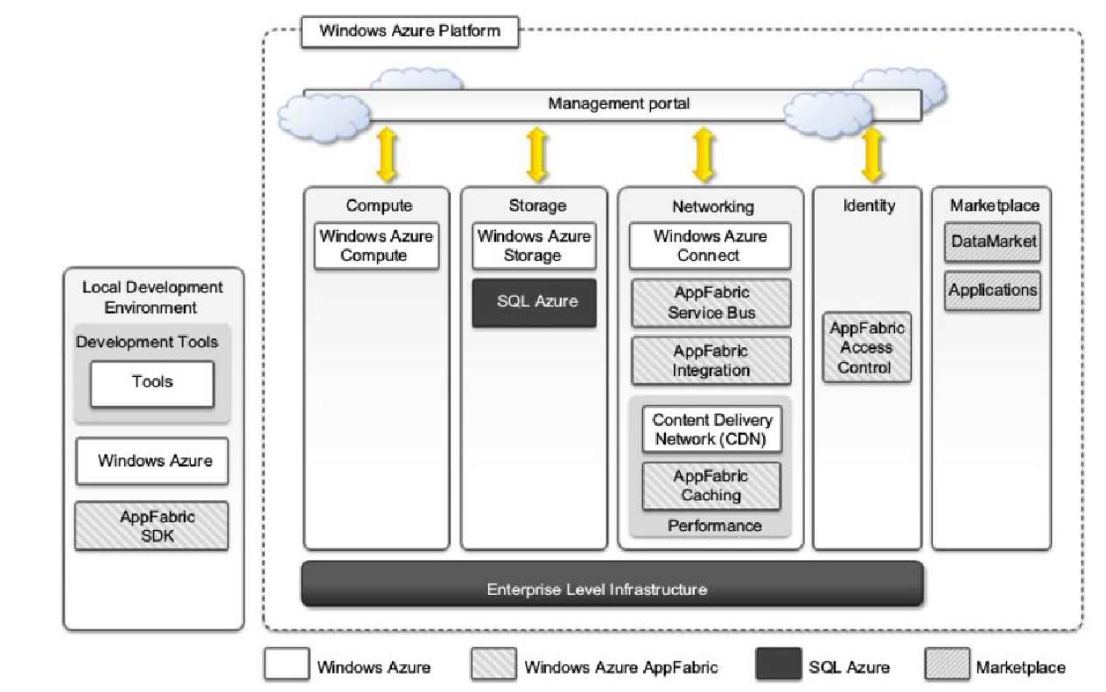
Figure 5.3: Microsoft window Azure platform architecture
These services can be managed and controlled through the Windows Azure Management Portal, which acts as an administrative console for all the services offered by the Azure platform.
Azure core concepts
The Windows Azure platform is made up of a foundation layer and a set of developer services that can be used to build scalable applications. These services cover compute, storage, networking, and identity management, which are tied together by middleware called AppFabric.
Compute services
Compute services are the core components of Microsoft Windows Azure, and they are delivered by means of the abstraction of roles. Currently, there are three different roles: Web role, Worker role, and Virtual Machine (VM) role.
Web role- The Web role is designed to implement scalable Web applications. Web roles represent the units of deployment of Web applications within the Azure infrastructure. They are hosted on the IIS 7 Web Server. Since version 3.5, the .NET technology natively supports Web roles; developers can directly develop their applications in Visual Studio, test them locally, and upload to Azure. Web roles can be used to run and scale PHP Web applications on Azure (CGI Web Role).
Worker role - Worker roles are designed to host general compute services on Azure. They can be used to quickly provide compute power or to host services that do not communicate with the external world through HTTP. A common practice for Worker roles is to use them to provide background processing for Web applications developed with Web roles. A Worker role runs continuously from the creation of its instance until it is shut down. The Azure SDK provides developers with convenient APIs and libraries that allow connecting the role with the service provided by the runtime and easily controlling its startup as well as being notified of changes in the hosting environment.
Virtual machine role- The Virtual Machine role allows developers to control computing stack of their compute service by defining a custom image of the Windows Server 2008 R2 operating system and all the service stack required by their applications. The Virtual Machine role is based on the Windows Hyper-V virtualization technology. Developers can image a Windows server installation complete with all the required applications and components, save it into a Virtual Hard Disk (VHD).
Storage services
Compute resources are equipped with local storage in the form of a directory on the local file system. Windows Azure provides different types of storage solutions that complement compute services with a more durable and redundant option.
Blobs
Azure allows storing large amount of data in the form of binary large objects (BLOBs) by means of the blobs service.
Block blobs - Block blobs are composed of blocks and are optimized for sequential access; therefore they are appropriate for media streaming. Currently, blocks are of 4 MB, and a single block blob can reach 200 GB in dimension.
Page blobs - Page blobs are made of pages that are identified by offset from beginning of blob. A page blob can be split into multiple pages or constituted of single page. This type of blob is optimized for random access and can be used to host data different from streaming. Maximum dimension of page blob can be 1TB.
Azure drive
Page blobs can be used to store an entire file system in the form of a single Virtual Hard Drive (VHD) file. This can then be mounted as a part of the NTFS file system by Azure compute resources, thus providing persistent and durable storage.
Tables
Tables constitute a semistructured storage solution, allowing users to store information in the form of entities with a collection of properties. Entities are stored as rows in the table and are identified by a key, which also constitutes the unique index built for the table. Users can insert, update, delete, and select a subset of the rows stored in the table. Currently, a table can contain up to 100 TB of data, and rows can have up to 255 properties, with a maximum of 1 MB for each row. The maximum dimension of a row key and partition keys is 1 KB.
Queues
Queue storage allows applications to communicate by exchanging messages through durable queues, thus avoiding lost or unprocessed messages. Applications enter messages into a queue, and other applications can read them in a first-in, first-out (FIFO) style.
Core infrastructure: AppFabric
AppFabric is a comprehensive middleware for developing, deploying, and managing applications on the cloud or for integrating existing applications with cloud services. AppFabric implements an optimized infrastructure supporting scaling out and high availability; sandboxing and multitenancy; state management; and dynamic address resolution and routing.
Access control- AppFabric provides the capability of encoding access control to resources in Web applications and services into a set of rules that are expressed outside the application code base. These rules give a great degree of flexibility in terms of the ability to secure components of the application and define access control policies for users and groups.
Service bus - Service Bus constitutes the messaging and connectivity infrastructure provided with AppFabric for building distributed and disconnected applications The service is designed to allow transparent network traversal and to simplify the development of loosely coupled applications, without renouncing security and reliability and letting developers focus on the logic of the interaction rather than the details of its implementation. Service Bus allows services to be available by simple URLs, which are untied from their deployment location.
Azure cache- Windows Azure provides a set of durable storage solutions that allow applications to persist their data. Azure Cache is a service that allows developers to quickly access data persisted on Windows Azure storage or in SQL Azure. The service implements a distributed in-memory cache of which the size can be dynamically adjusted by applications according to their needs.
Other services
Windows Azure virtual network- Networking services for applications are offered under the name Windows Azure Virtual Network, which includes Windows Azure Connect and Windows Azure Traffic Manager. Windows Azure Connect allows easy setup of IP-based network connectivity among machines hosted on the private premises and the roles deployed on the Azure Cloud. This service is particularly useful in the case of VM roles.
Windows Azure content delivery network- Windows Azure Content Delivery Network (CDN) is the content delivery network solution that improves the content delivery capabilities of Windows Azure Storage and several other Microsoft services, such as Microsoft Windows Update and Bing maps.
SQL Azure
SQL Azure is a relational database service hosted on Windows Azure and built on the SQL Server
technologies. The service extends the capabilities of SQL Server to the cloud and provides developers with a scalable, highly available, and fault-tolerant relational database. SQL Azure is accessible from either the Windows Azure Cloud or any other location that has access to the Azure Cloud. It is fully compatible with the interface exposed by SQL Server, so applications built for SQL Server can transparently migrate to SQL Azure.

Figure 5.4 shows the architecture of SQL Azure. Access to SQL Azure is based on the Tabular Data Stream (TDS) protocol, which is the communication protocol underlying all the different interfaces used by applications to connect to a SQL Server-based installation such as ODBC and ADO.NET.

Developers have to sign up for a Windows Azure account in order to use SQL Azure. Once the account is activated, they can either use the Windows Azure Management Portal or the REST APIs to create servers and logins and to configure access to servers. SQL Azure servers are abstractions that closely resemble physical SQL Servers: They have a fully qualified domain name under the database.windows.net (i.e., server-name.database.windows.net) domain name.
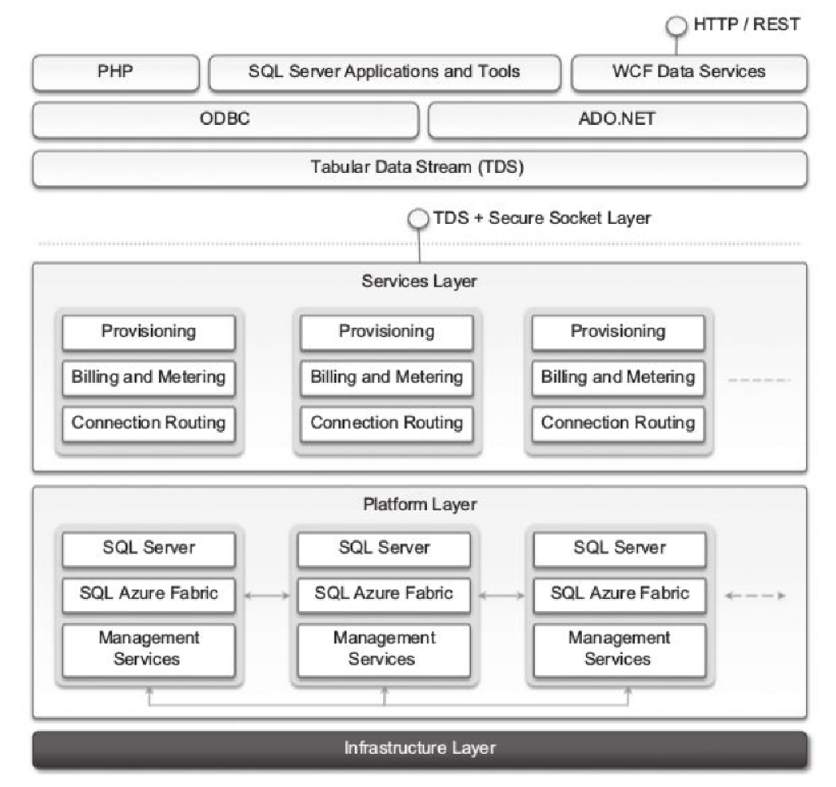
Figure 5.4: SQL Azure architecture
This simplifies the management tasks and the interaction with SQL Azure from client applications.
Currently, two different editions are available: Web Edition and Business Edition. The former is suited for small Web applications and supports databases with a maximum size of 1 GB or 5 GB. The latter is suited for independent software vendors, line-of-business applications, and enterprise applications and supports databases with a maximum size from 10 GB to 50 GB, in increments of 10 GB.
Windows Azure platform appliance
The Windows Azure platform can also be deployed as an appliance on third-party data centers and constitutes the cloud infrastructure governing the physical servers of the datacenter. The Windows Azure Platform Appliance includes Windows Azure, SQL Azure, and Microsoft- specified configuration of network, storage, and server hardware. The appliance is a solution that targets governments and service providers who want to have their own cloud computing infrastructure.
Observations
Windows Azure is Microsoft’s solution for developing cloud computing applications. Azure is an Implementation of the PaaS layer and provides the developer with a collection of services and scalable middleware hosted on Microsoft datacenters that address compute, storage, networking, and identity management needs of applications. The core components of the platform are composed of compute services, storage services, and middleware.

Compute services are based on the abstraction of roles, which identify a sandboxed environment where developers can build their distributed and scalable components. SQL Azure is another important element of Windows Azure and provides support for relational data in the cloud. SQL Azure is an extension of the capabilities of SQL Server adapted for the cloud environment and designed for dynamic scaling.

Cloud applications
Cloud computing has gained huge popularity in industry due to its ability to host applications for which the services can be delivered to consumers rapidly at minimal cost. This chapter discusses some application case studies, detailing their architecture and how they leveraged various cloud technologies. Applications from a range of domains, from scientific to engineering, gaming, and social networking, are considered.
Scientific Applications
Scientific applications are a sector that is increasingly using cloud computing systems and technologies. Cloud computing systems meet the needs of different types of applications in the scientific domain: high-performance computing (HPC) applications, high-throughput computing (HTC) applications, and data-intensive applications. The opportunity to use cloud resources is even more appealing because minimal changes need to be made to existing applications in order to leverage cloud resources.
Healthcare: ECG analysis in the cloud
Healthcare is a domain in which computer technology has found several and diverse applications: from supporting the business functions to assisting scientists in developing solutions to cure diseases. An illustration of the infrastructure and model for supporting remote ECG monitoring is shown in figure 5.5 Wearable computing devices equipped with ECG sensors constantly monitor the patient’s heartbeat. Such information is transmitted to the patient’s mobile device, which will eventually forward it to the cloud-hosted Web service for analysis.
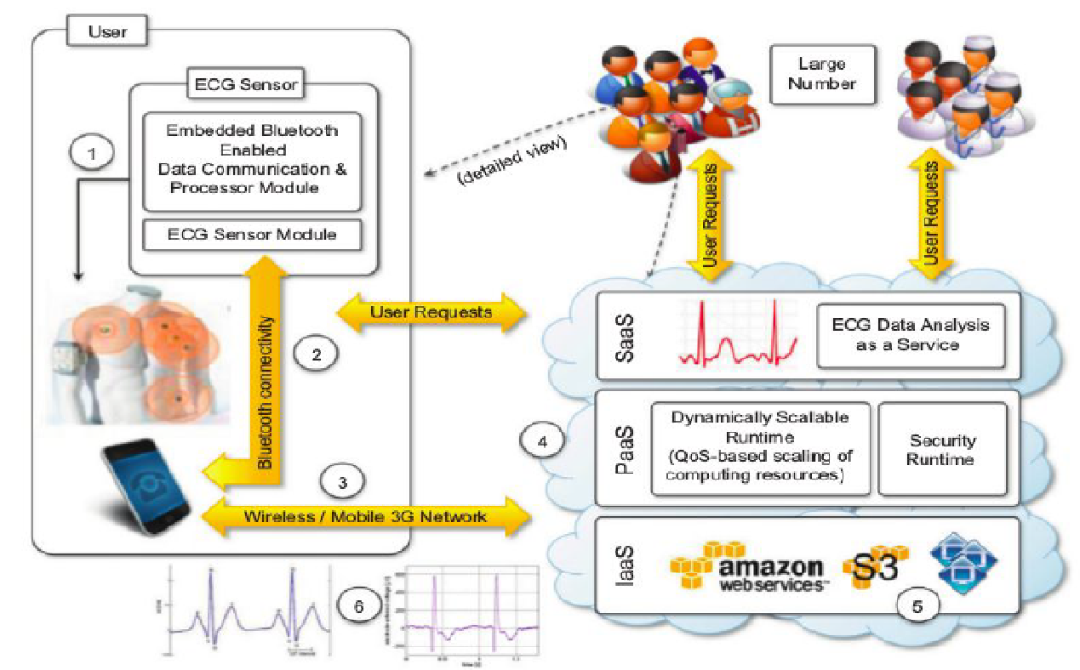
Figure 5.5: An online health monitoring system hosted in the cloud
The Web service forms the front-end of a platform that is hosted in cloud and leverages three layers of cloud computing stack: SaaS, PaaS, and IaaS. The Web service constitute SaaS application that will store ECG data in the Amazon S3 service and issue a processing request to the scalable cloud platform.
The runtime platform is composed of a dynamically sizable number of instances running the workflow engine and Aneka. The number of workflow engine instances is controlled according to the number of requests in the queue of each instance, while Aneka controls the number of EC2 instances used to execute the single tasks defined by the workflow engine for a single ECG processing job.
Advantages
1. The elasticity of cloud infrastructure that can grow and shrink according to the requests served. As a result, doctors and hospitals do not have to invest in large computing infrastructures designed after capacity planning, thus making more effective use of budgets.
2. Ubiquity. Cloud computing technologies are easily accessible and promise to deliver systems with minimum or no downtime. Computing systems hosted in cloud are accessible from any Internet device through simple interfaces (such as SOAP and REST-based Web services). This makes systems easily integrated with other systems maintained on hospital’s premises.
3. Cost savings. Cloud services are priced on a pay-per-use basis and with volume prices for large numbers of service requests.
Biology: protein structure prediction
Applications in biology require high computing capabilities and operate on large data-sets that cause extensive I/O operations. Therefore biology applications have made use of supercomputing and cluster computing infrastructures. Similar capabilities can be leveraged using cloud computing technologies in a more dynamic fashion, thus opening new opportunities for bioinformatics applications. Protein structure prediction is a computationally intensive task that is fundamental to different types of research in the life sciences.
The geometric structure of a protein cannot be directly inferred from the sequence of genes that compose its structure, but it is the result of complex computations aimed at identifying the structure that minimizes the required energy. This task requires the investigation of a space with a massive number of states, consequently creating a large number of computations for each of these states.
One project that investigates the use of cloud technologies for protein structure prediction is Jeeva – an integrated Web portal that enables scientists to offload the prediction task to a computing cloud based on Aneka The prediction task uses machine learning techniques (support vector machines) for determining the secondary structure of proteins. It’s as shown in figure 5.6.
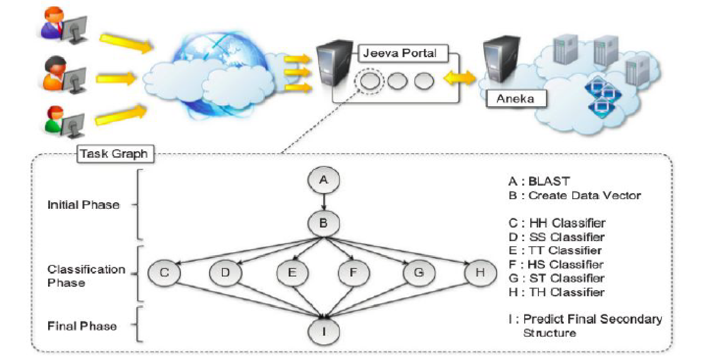
Figure 5.6: Architecture and overview of Jeeva portal
A popular implementation based on support vector machines divides the pattern recognition problem into three phases: initialization, classification, and a final phase. These three phases have to be executed in sequence, we can perform parallel execution in the classification phase, where multiple classifiers are executed concurrently.
This reduces computational time of the prediction. The prediction algorithm is then translated into a task graph that is submitted to Aneka. Once the task is completed, the middleware makes the results available for visualization through the portal. The advantage of using cloud technologies is the capability to leverage a scalable computing infrastructure that can be grown and shrunk on demand.

Biology: gene expression data analysis for cancer diagnosis
Gene expression profiling is the measurement of the expression levels of thousands of genes at once. It is used to understand the biological processes that are triggered by medical treatment at a cellular level. Important application of gene expression profiling is cancer diagnosis and treatment. Cancer is a disease characterized by uncontrolled cell growth and proliferation. This behavior occurs because genes regulating the cell growth mutate. Gene expression profiling is utilized to provide a more accurate classification of tumors.

The dimensionality of typical gene expression datasets ranges from several thousands to over tens of thousands of genes. This problem is approached with learning classifiers, which generate a population of condition-action rules that guide the classification process. The eXtended Classifier System (XCS) has been utilized for classifying large datasets in bioinformatics and computer science domains.
A variation of this algorithm, CoXCS [162], has proven to be effective in these conditions. CoXCS divides the entire search space into subdomains and employs the standard XCS algorithm in each of these subdomains. Such a process is computationally intensive but can be easily parallelized because the classifications problems on the subdomains can be solved concurrently.
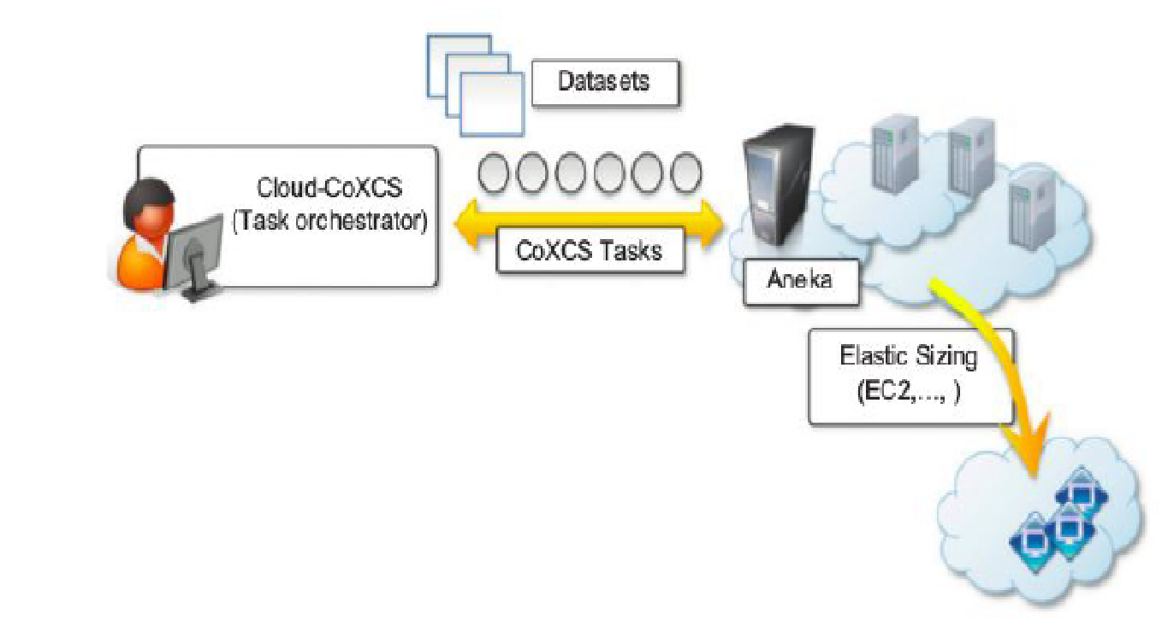
Figure 5.7: Cloud-coXCS: An environment for microarray data processing on the cloud
Cloud-CoXCS (Figure 5.7) is a cloud-based implementation of CoXCS that leverages Aneka to solve the classification problems in parallel and compose their outcomes. The algorithm is controlled by strategies, which define the way the outcomes are composed together and whether the process needs to be iterated.
Geoscience: satellite image processing
Geoscience applications collect, produce, and analyze massive amounts of geospatial and nonspatial data. As the technology progresses and our planet becomes more instrumented, volume of data that needs to be processed increases significantly. Geographic information system (GIS) applications capture, store, manipulate, analyze, manage, and present all types of geographically referenced data.
Cloud computing is an attractive option for executing these demanding tasks and extracting meaningful information to support decision makers. Satellite remote sensing generates hundreds of gigabytes of raw images that need to be further processed to become the basis of several different GIS products. This process requires both I/O and compute-intensive tasks. Large images need to be moved from a ground station’s local storage to compute facilities, where several transformations and corrections are applied.
The system shown in Figure 5.8 integrates several technologies across the entire computing stack.
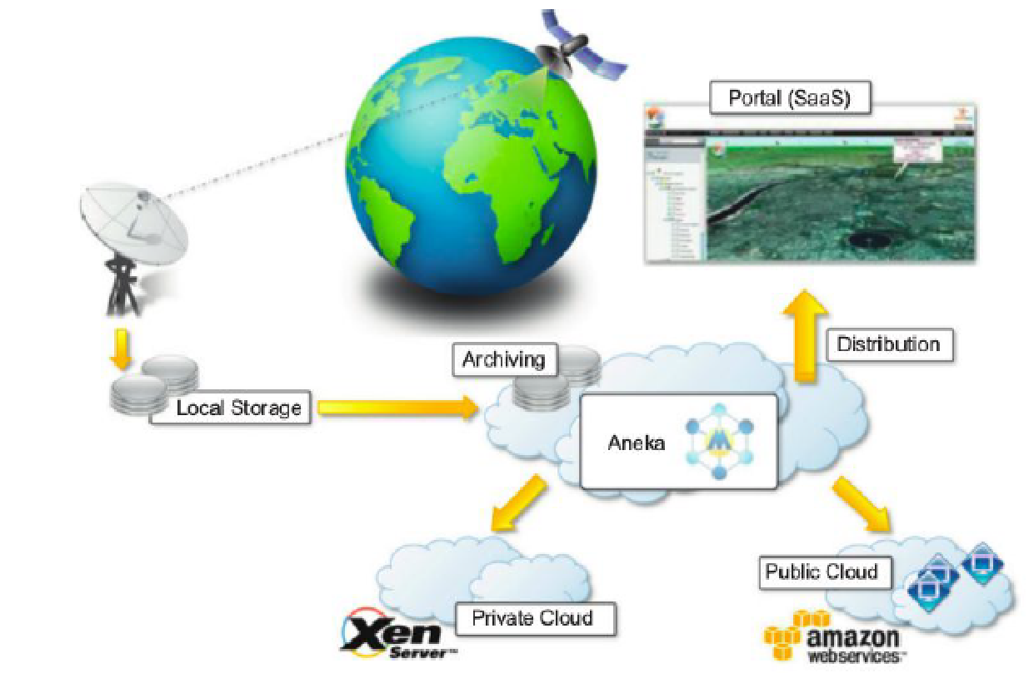
Figure 5.8: A cloud environment for satellite data processing
A SaaS application provides a collection of services for such tasks as geocode generation and data
Visualization. At the PaaS level, Aneka controls the importing of data into the virtualized infrastructure and the execution of image-processing tasks that produce the desired outcome from raw satellite images. The platform leverages a Xen private cloud and the Aneka technology to dynamically provision the required resources.
Business and consumer applications
The business and consumer sector is the one that benefits the most from cloud computing technologies. On one hand, the opportunity to transform capital costs into operational costs makes clouds an attractive option for all enterprises that are IT-centric. On the other hand, the sense of ubiquity that the cloud offers for accessing data and services makes it interesting for end users. The combination of all these elements has made cloud computing the preferred technology for a wide range of applications.

CRM and ERP
Customer relationship management (CRM) and enterprise resource planning (ERP) applications are market segments that are flourishing in the cloud CRM applications constitute a great opportunity for small enterprises and start-ups to have fully functional CRM software without large up-front costs and by paying subscriptions. Your business and customer data from everywhere and from any device, has fostered the spread of cloud CRM applications.
ERP solutions on the cloud are less mature and have to compete with well-established in-house solutions. ERP systems integrate several aspects of an enterprise: finance and accounting, human resources, manufacturing, supply chain management, project management, and CRM.
Salesforce.com
Salesforce.com is most popular and developed CRM solution available today. As of today more than 100,000 customers have chosen Safesforce.com to implement their CRM solutions. The application provides customizable CRM solutions that can be integrated with additional features developed by third parties. Salesforce.com is based on the Force.com cloud development platform.
This represents scalable and high-performance middleware executing all operations of all Salesforce.com applications. The architecture of the Force.com platform is shown in Figure 5.9.

At the core of the platform resides its metadata architecture, which provides the system with flexibility and scalability. Application core logic and business rules are saved as metadata into the Force.com store. Both application structure and application data are stored in the store. A runtime engine executes application logic by retrieving its metadata and then performing the operations on the data. A full-text search engine supports the runtime engine. This allows application users to have an effective user experience the search engine maintains its indexing data in a separate store.

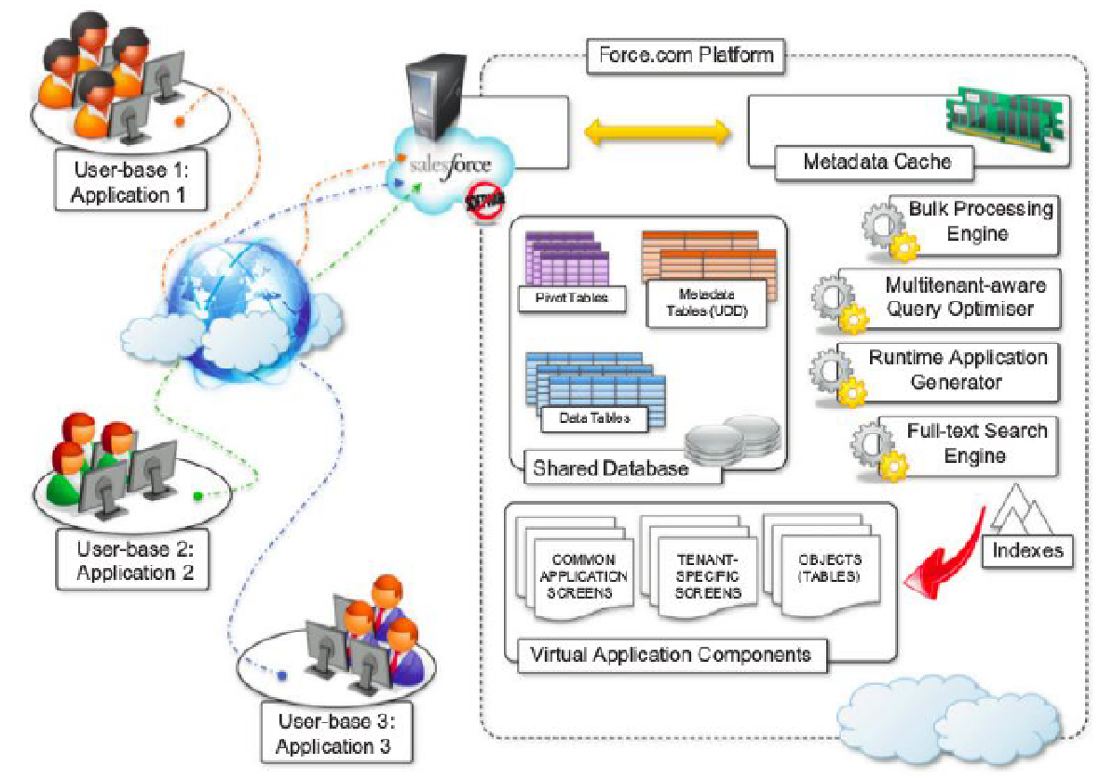
Figure 5.9: Salesforce.com and Force.com architecture

Microsoft dynamics CRM
The system is completely hosted in Microsoft’s datacenters across the world and offers to customers a 99.9% SLA. Each CRM instance is deployed on a separate database, and application provides users with facilities for marketing, sales, and advanced customer relationship management.
Dynamics CRM Online features can be accessed either through a Web browser interface or by means of SOAP and RESTful Web services. This allows Dynamics CRM to be easily integrated with both other Microsoft products and line-of-business applications. Dynamics CRM can be extended by developing plug-ins that allow implementing specific behaviors triggered on the occurrence of given events.
NetSuite
NetSuite provides a collection of applications that help customers manage every aspect of the business enterprise. Its offering is divided into three major products: NetSuite Global ERP, NetSuite Global CRM1, and NetSuite Global Ecommerce. Moreover, an all-in-one solution: NetSuite One World, integrates all three products together. The services NetSuite delivers are powered by two large datacenters on the East and West coasts of the United States, connected by redundant links. This allows NetSuite to guarantee 99.5% uptime to its customers. The NetSuite Business Operating System (NS-BOS) is a complete stack of technologies for building SaaS business applications that leverage the capabilities of NetSuite products. On top of the SaaS infrastructure, the NetSuite Business Suite components offer accounting, ERP, CRM, and ecommerce capabilities.
Productivity
Productivity applications replicate in cloud. The most common tasks that we are used to performing on our desktop: from document storage to office automation and complete desktop environments hosted in the cloud.
Dropbox and iCloud
The most popular solution for online document storage is Dropbox that allows users to synchronize any file across any platform and any device in a seamless manner (Figure 5.10). Dropbox provides users with a free storage that is accessible through the abstraction of a folder. Users can either access their Dropbox folder through a browser or by downloading and installing a Dropbox client, which provides access to the online storage by means of a special folder. All the modifications into this folder are silently synched so that changes are notified to all the local instances of the Dropbox folder across all the devices.

Another interesting application in this area is iCloud, a cloud-based document-sharing application provided by Apple to synchronize iOS-based devices in a completely transparent manner. Documents, photos, and videos are automatically synched as changes are made, without any explicit operation. This allows the system to efficiently automate common operations without any human intervention. This capability is limited to iOS devices, and currently there are no plans to provide iCloud with a Web-based interface that would make user content accessible from even unsupported platforms.
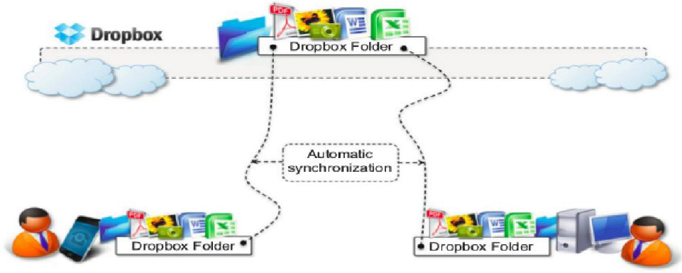
Figure 5.10: Dropbox usage scenario
Google docs
Google Docs is a SaaS application that delivers the basic office automation capabilities with support for collaborative editing over the Web. Google Docs allows users to create and edit text documents, spreadsheets, presentations, forms, and drawings. It aims to replace desktop products such as Microsoft Office and OpenOffice and provide similar interface and functionality as a cloud service.
By being stored in the Google infrastructure, these documents are always available from anywhere and from any device that is connected to the Internet. Google Docs is a good example of what cloud computing can deliver to end users: ubiquitous access to resources, elasticity, absence of installation and maintenance costs, and delivery of core functionalities as a service.
Cloud desktops: EyeOS and XIOS/3
EyeOS is one of the most popular Web desktop solutions based on cloud technologies. It replicates the functionalities of a classic desktop environment and comes with pre-installed applications for the most common file and document management tasks (Figure 5.11). Single users can access the EyeOS desktop environment from anywhere and through any Internet-connected device, whereas organizations can create a private EyeOS Cloud on their premises to virtualize the desktop environment of their employees and centralize their management.
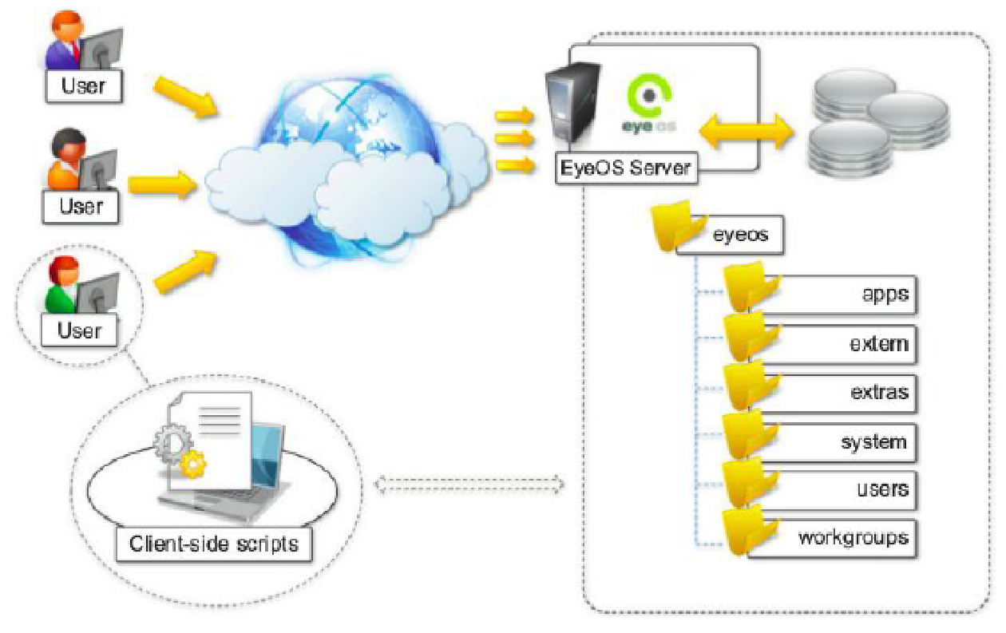
Figure 5.11: EyeOS architecture
The EyeOS architecture is quite simple: On the server side, the EyeOS application maintains the information about user profiles and their data, and the client side constitutes the access point for users and administrators to interact with the system. EyeOS stores the data about users and applications on the server file system. Once the user has logged in by providing credentials, the desktop environment is rendered in the client’s browser by downloading all the JavaScript libraries required to build the user interface and implement the core functionalities of EyeOS.
Xcerion XML Internet OS/3 (XIOS/3) is another example of a Web desktop environment. The service is delivered as part of the CloudMe application, which is a solution for cloud document storage. The key differentiator of XIOS/3 is its strong leverage of XML, used to implement many of the tasks of the OS: rendering user interfaces, defining application business logics, structuring file system organization, and even application development.

Social networking
Social networking applications have grown considerably in the last few years to become the most active sites on the Web. To sustain their traffic and serve millions of users seamlessly, services such as Twitter and Facebook have leveraged cloud computing technologies.
Facebook
Facebook is probably the most evident and interesting environment in social networking. With more than 800 million users, it has become one of the largest Websites in the world. To sustain this incredible growth, it has been fundamental that Facebook be capable of continuously adding capacity and developing new scalable technologies and software systems while maintaining high performance to ensure a smooth user experience. Currently, the social network is backed by two data centers that have been built and optimized to reduce costs and impact on the environment.

On top of this highly efficient infrastructure, built and designed out of inexpensive hardware, a completely customized stack of opportunely modified and refined open-source technologies constitutes the back-end of the largest social network. The reference stack serving Facebook is based on LAMP (Linux, Apache, MySQL, and PHP). This collection of technologies is accompanied by a collection of other services developed in-house. These services are developed in a variety of languages and implement specific functionalities such as search, news feeds, notifications, and others.
While serving page requests, the social graph of the user is composed. The social graph identifies a collection of interlinked information that is of relevance for a given user. Most of the user data are served by querying a distributed cluster of MySQL instances, which mostly contain key-value pairs.

Media applications
Media applications has taken a considerable advantage from leveraging cloud computing technologies. The computationally intensive tasks can be easily offloaded to cloud computing infrastructures.
Animoto
Animoto is the most popular example of media applications on the cloud. The Website provides users with a very straightforward interface for quickly creating videos out of images, music, and video fragments submitted by users. Users select a specific theme for a video, upload the photos and videos and order them in the sequence they want to appear, select the song for the music, and render the video.
The process is executed in the background and the user is notified via email once the video is rendered. A proprietary artificial intelligence (AI) engine, which selects the animation and transition effects according to pictures and music, drives the rendering operation. Users only have to define the storyboard by organizing pictures and videos into the desired sequence.

The infrastructure of Animoto is complex and is composed of different systems that all need to scale (Figure 5.12). The core function is implemented on top of the Amazon Web Services infrastructure. It uses Amazon EC2 for the Web front-end and worker nodes; Amazon S3 for the storage of pictures, music, and videos; and Amazon SQS for connecting all the components.
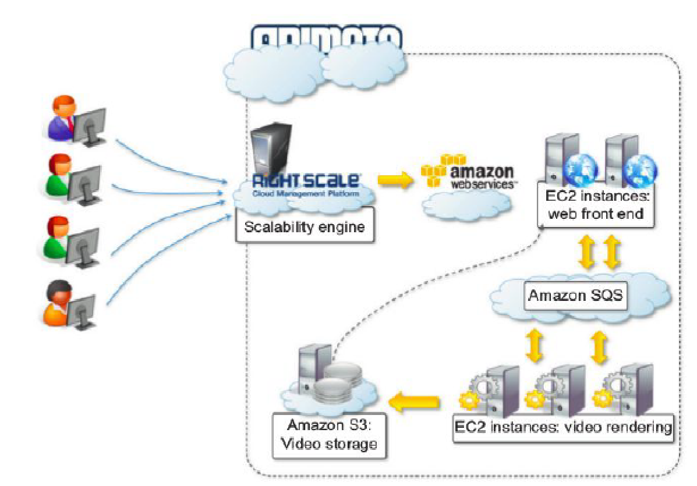
Figure 5.12: Animoto reference architecture
Maya rendering with Aneka
A private cloud solution for rendering train designs has been implemented by the engineering department of GoFront group, a division of China Southern Railway (Figure 5.13). The department is responsible for designing models of high-speed electric locomotives, metro cars, urban transportation vehicles, and motor trains. The design process for prototypes requires high-quality, three-dimensional (3D) images.
The analysis of these images can help engineers identify problems and correct their design. Three-dimensional rendering tasks take considerable amounts of time, especially in the case of huge numbers of frames, but it is critical for the department to reduce the time spent in these iterations. This goal has been achieved by leveraging cloud computing technologies, which turned the network of desktops in the department into a desktop cloud managed by Aneka.
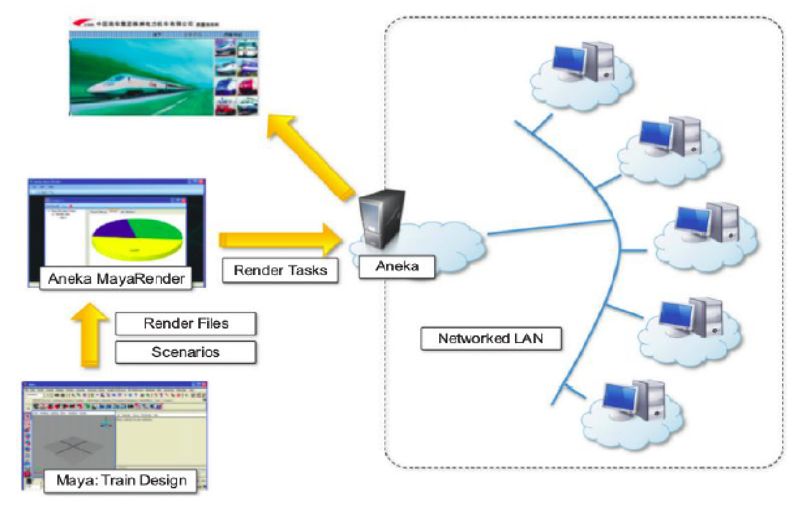
Figure 5.13: 3D rendering in private clouds

Video encoding on the cloud: Encoding.com
Video encoding and transcoding are operations that can greatly benefit from using cloud technologies: They are computationally intensive and potentially require considerable amounts of storage. Encoding.com is a software solution that offers video-transcoding services on demand and leverages cloud technology to provide both the horsepower required for video conversion and the storage for staging videos.
The service integrates with both Amazon Web Services technologies (EC2, S3, and CloudFront) and Rackspace (Cloud Servers, Cloud Files, and Limelight CDN access). To use the service, users have to specify the location of the video to transcode, the destination format, and the target location of the video. Encoding.com also offers other video-editing operations such as the insertion of thumbnails, watermarks, or logos. Moreover, it extends its capabilities to audio and image conversion.
Multiplayer online gaming
Online multiplayer gaming attracts millions of gamers around the world who share a common experience by playing together in a virtual environment that extends beyond the boundaries of a normal LAN. Online games support hundreds of players in the same session, made possible by the specific architecture used to forward interactions, which is based on game log processing.

Players update the game server hosting the game session, and the server integrates all the updates into a log that is made available to all the players through a TCP port. The client software used for the game connects to the log port and, by reading the log, updates the local user interface with the actions of other players.
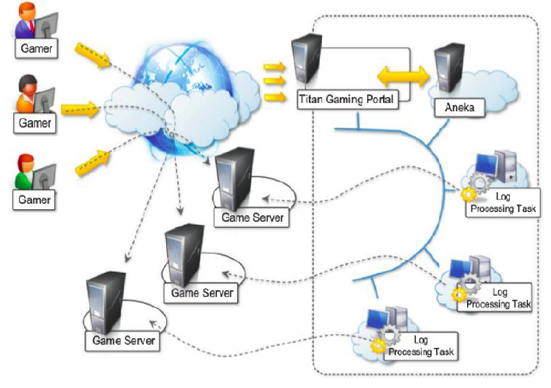
Figure 5.14: Scalable processing of logs for network games

Game log processing is also utilized to build statistics on players and rank them. These features constitute the additional value of online gaming portals that attract more and more gamers. The processing of game logs is a potentially compute-intensive operation that strongly depends on the number of players online and the number of games monitored.

The use of cloud computing technologies can provide the required elasticity for seamlessly processing these workloads and scale as required when the number of users increases. A prototype implementation of cloud-based game log processing has been implemented by Titan Inc. (Figure 5.14).

